Contents
Application Screenshots 3
Main Menu (MainActivity) 3
Game Mode Selection and Level Selection (LevelSelectionActivity) 4
Compare Numbers Game (CompareActivity) 5
Order Numbers Game (OrderActivity) 6
Compose Numbers Game (ComposeActivity) 7
Score Summary Page (ScoreActivity) 8
Appendix 9
MainActivity.java 9
activity_main.xml 10
LevelSelectionActivity.java 12
activity_level_selection.xml 14
CompareActivity.java 16
activity_compare.xml 19
OrderActivity.java 22
activity_order.xml 27
ComposeActivity.java 30
activity_compose.xml 35
ScoreActivity.java 38
activity_score.xml 39

Application Screenshots

Main Menu (MainActivity)
This is the main screen of the app where users are welcomed and presented with a Start Game button. It serves as a friendly and minimal introduction to the app.
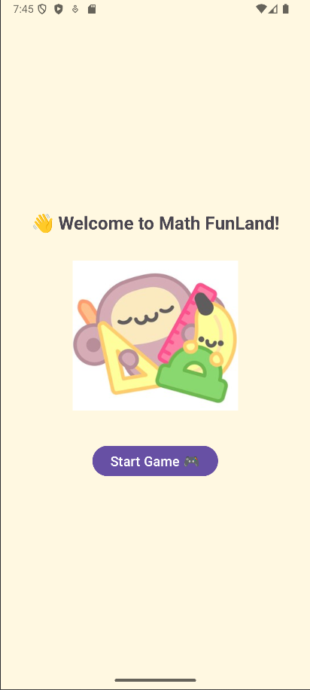

Game Mode Selection and Level Selection (LevelSelectionActivity)
Users choose between Compare Numbers, Order Numbers, or Compose Numbers. This screen allows users to select the game type before choosing the difficulty, there are 3 different level which is Level 1: 1-digit numbers, Level 2: 2-digit numbers and Level 3: 3-digit numbers.
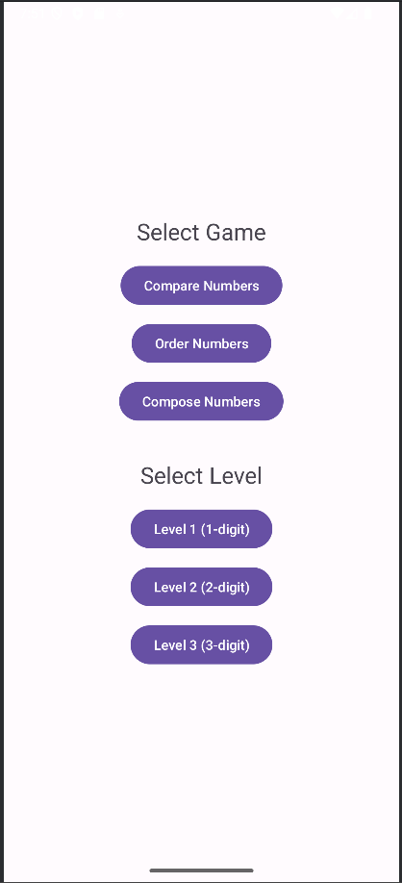

Compare Numbers Game (CompareActivity)
This screen presents two numbers side-by-side with a prompt:
“Which is Bigger?” or “Which is Smaller?”
The user selects either Left or Right, the image will change when the user chooses the correct or wrong answer and will show the score at the end after 10 questions.
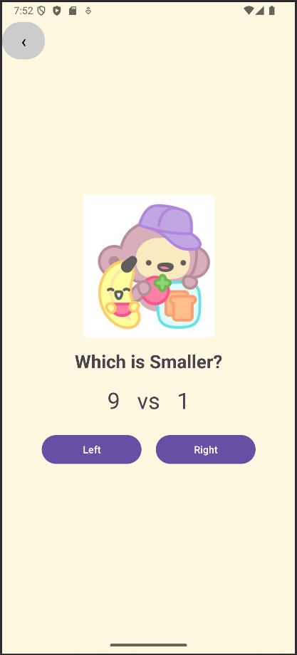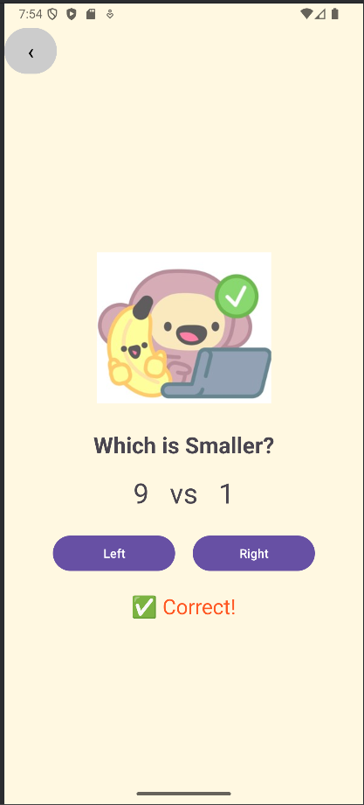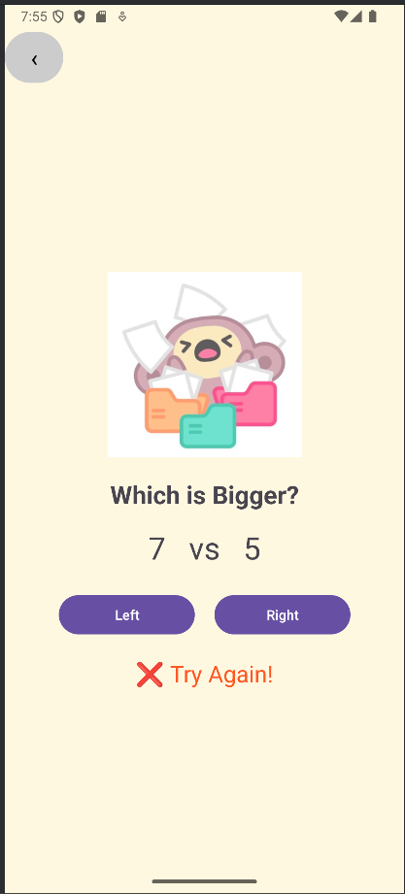
Order Numbers Game (OrderActivity)
User is prompted to arrange 5 numbers in either ascending or descending order by selecting from the options below. The image will change when the user chooses the correct or wrong answer and will show the score at the end after 10 questions.
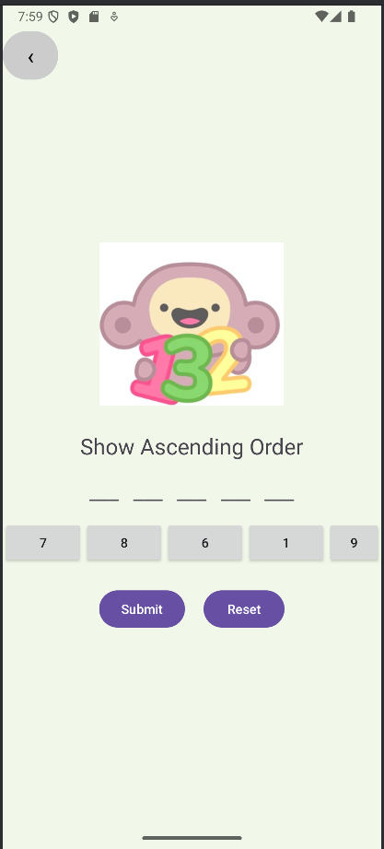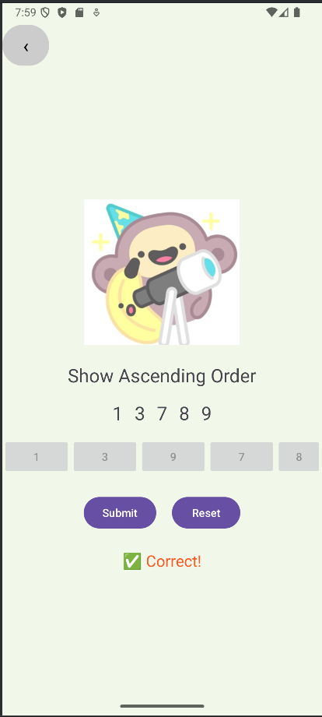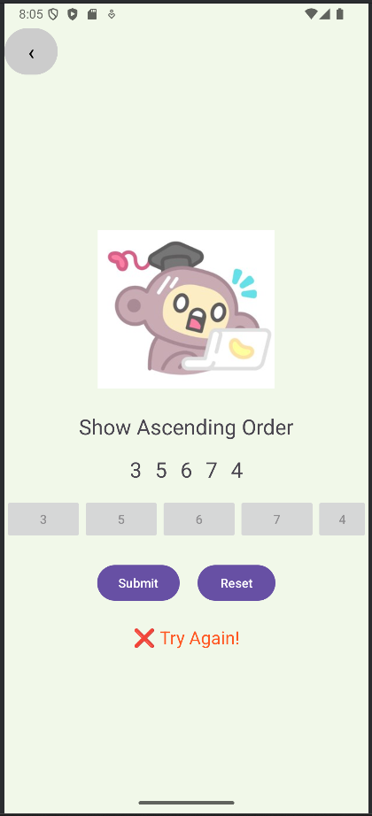
User can also choose to reset their anwser if they found out they have miss the answer.
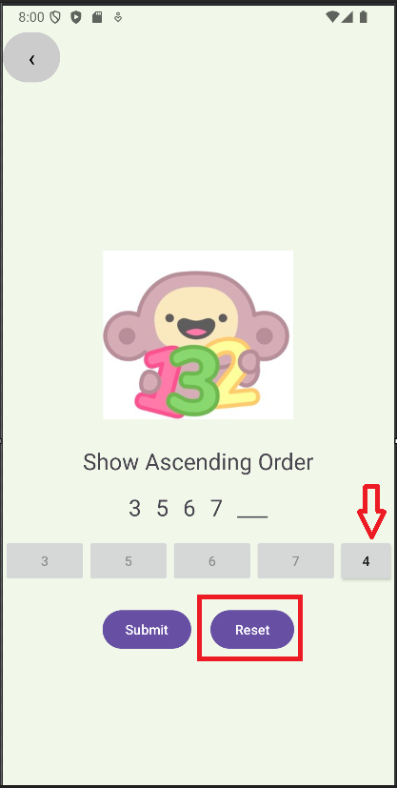
Compose Numbers Game (ComposeActivity)
User is shown a target number and must tap two numbers that add up to it (without seeing any math symbols), the image will change when the user chooses the correct or wrong answer and will show the score at the end after 10 questions. There is also a reset button for user if they make mistakes.
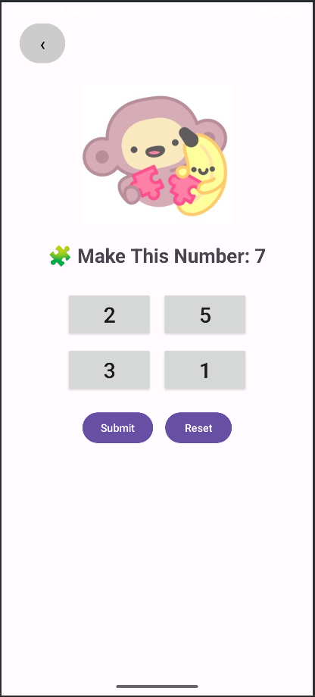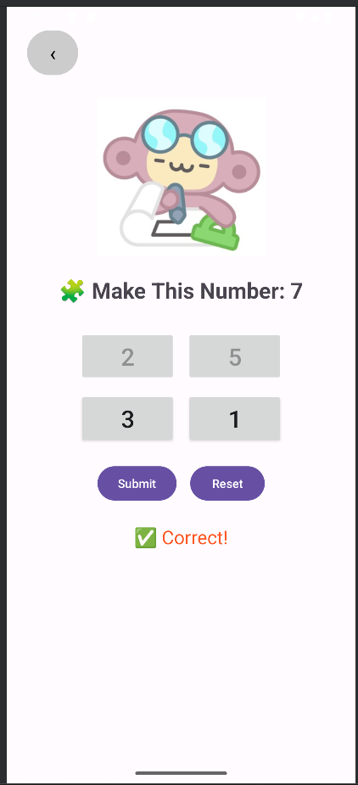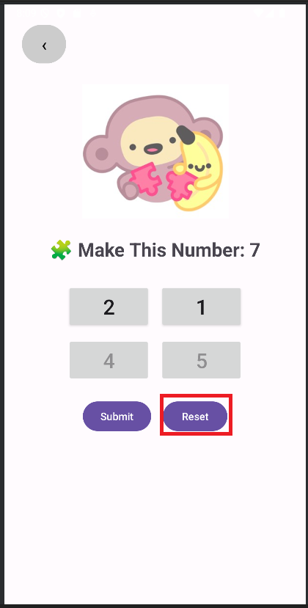

Score Summary Page (ScoreActivity)
At the end of each game mode, the app shows a score summary screen. It displays how many questions the user answered correctly out of 10.
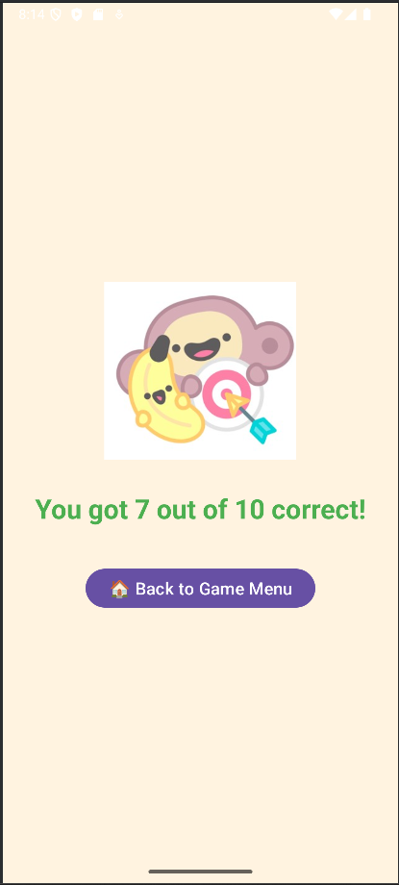
Back Navigation
Each game screen includes a minimal back button (‹) in the top-left corner that allows returning to the game selection screen.
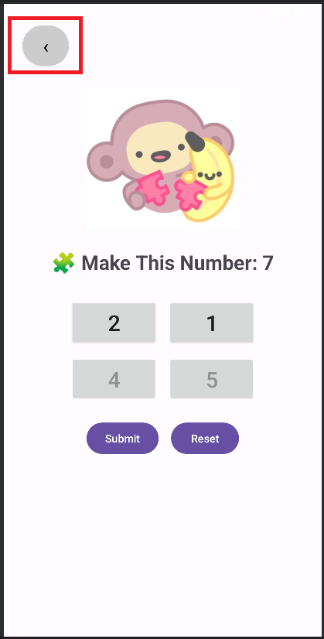

Appendix

MainActivity.java
package com.example.individualassignment;
import android.content.Intent;
import android.os.Bundle;
import android.widget.Button;
import androidx.activity.EdgeToEdge;
import androidx.appcompat.app.AppCompatActivity;
import androidx.core.graphics.Insets;
import androidx.core.view.ViewCompat;
import androidx.core.view.WindowInsetsCompat;
public class MainActivity extends AppCompatActivity {
@Override
protected void onCreate(Bundle savedInstanceState) {
super.onCreate(savedInstanceState);
EdgeToEdge.enable(this);
setContentView(R.layout.activity_main);
ViewCompat.setOnApplyWindowInsetsListener(findViewById(R.id.main), (v, insets) -> {
Insets systemBars = insets.getInsets(WindowInsetsCompat.Type.systemBars());
v.setPadding(systemBars.left, systemBars.top, systemBars.right, systemBars.bottom);
return insets;
});
Button btnStartGame = findViewById(R.id.btnStartGame);
btnStartGame.setOnClickListener(v -> {
Intent intent = new Intent(this, LevelSelectionActivity.class);
startActivity(intent);
});
}
}

activity_main.xml
<?xml version="1.0" encoding="utf-8"?>
<LinearLayout xmlns:android="http://schemas.android.com/apk/res/android"
android:id="@+id/main"
android:layout_width="match_parent"
android:layout_height="match_parent"
android:orientation="vertical"
android:background="#FFF8E1"
android:padding="32dp">
<!-- Top spacer -->
<View
android:layout_width="match_parent"
android:layout_height="0dp"
android:layout_weight="1" />
<!-- Centered content -->
<LinearLayout
android:layout_width="match_parent"
android:layout_height="wrap_content"
android:orientation="vertical"
android:gravity="center_horizontal">
<!-- Welcome text -->
<TextView
android:id="@+id/txtWelcome"
android:layout_width="wrap_content"
android:layout_height="wrap_content"
android:text="👋 Welcome to Math FunLand!"
android:textSize="24sp"
android:textStyle="bold"
android:layout_marginBottom="24dp" />
<!-- Mascot image -->
<ImageView
android:id="@+id/imgMascot"
android:layout_width="220dp"
android:layout_height="220dp"
android:src="@drawable/start"
android:layout_marginBottom="32dp"
android:contentDescription="Mascot" />
<!-- Start button -->
<Button
android:id="@+id/btnStartGame"
android:layout_width="wrap_content"
android:layout_height="wrap_content"
android:text="Start Game 🎮"
android:textSize="18sp" />
</LinearLayout>
<!-- Bottom spacer -->
<View
android:layout_width="match_parent"
android:layout_height="0dp"
android:layout_weight="1" />
</LinearLayout>

LevelSelectionActivity.java
package com.example.individualassignment;
import android.content.Intent;
import android.os.Bundle;
import android.widget.Button;
import android.widget.Toast;
import androidx.appcompat.app.AppCompatActivity;
public class LevelSelectionActivity extends AppCompatActivity {
private String selectedGame = null; // Initially no game selected
@Override
protected void onCreate(Bundle savedInstanceState) {
super.onCreate(savedInstanceState);
setContentView(R.layout.activity_level_selection);
Button btnCompare = findViewById(R.id.btnCompare);
Button btnOrder = findViewById(R.id.btnOrder);
Button btnCompose = findViewById(R.id.btnCompose);
Button btnLevel1 = findViewById(R.id.btnLevel1);
Button btnLevel2 = findViewById(R.id.btnLevel2);
Button btnLevel3 = findViewById(R.id.btnLevel3);
// Select game type
btnCompare.setOnClickListener(v -> {
selectedGame = "compare";
Toast.makeText(this, "Selected: Compare", Toast.LENGTH_SHORT).show();
});
btnOrder.setOnClickListener(v -> {
selectedGame = "order";
Toast.makeText(this, "Selected: Order", Toast.LENGTH_SHORT).show();
});
btnCompose.setOnClickListener(v -> {
selectedGame = "compose";
Toast.makeText(this, "Selected: Compose", Toast.LENGTH_SHORT).show();
});
// Handle level buttons only if a game has been selected
btnLevel1.setOnClickListener(v -> handleLevelSelected(1));
btnLevel2.setOnClickListener(v -> handleLevelSelected(2));
btnLevel3.setOnClickListener(v -> handleLevelSelected(3));
}
private void handleLevelSelected(int level) {
if (selectedGame == null) {
Toast.makeText(this, "Please select a game first!", Toast.LENGTH_SHORT).show();
return;
}
Intent intent;
switch (selectedGame) {
case "order":
intent = new Intent(this, OrderActivity.class);
break;
case "compose":
intent = new Intent(this, ComposeActivity.class);
break;
case "compare":
default:
intent = new Intent(this, CompareActivity.class);
break;
}
intent.putExtra("level", level);
startActivity(intent);
}
}

activity_level_selection.xml
<?xml version="1.0" encoding="utf-8"?>
<LinearLayout xmlns:android="http://schemas.android.com/apk/res/android"
android:id="@+id/main"
android:layout_width="match_parent"
android:layout_height="match_parent"
android:padding="24dp"
android:orientation="vertical"
android:gravity="center">
<TextView
android:layout_width="wrap_content"
android:layout_height="wrap_content"
android:text="Select Game"
android:textSize="24sp"
android:layout_marginBottom="16dp" />
<Button
android:id="@+id/btnCompare"
android:layout_width="wrap_content"
android:layout_height="wrap_content"
android:text="Compare Numbers" />
<Button
android:id="@+id/btnOrder"
android:layout_width="wrap_content"
android:layout_height="wrap_content"
android:text="Order Numbers"
android:layout_marginTop="12dp" />
<Button
android:id="@+id/btnCompose"
android:layout_width="wrap_content"
android:layout_height="wrap_content"
android:text="Compose Numbers"
android:layout_marginTop="12dp" />
<TextView
android:layout_width="wrap_content"
android:layout_height="wrap_content"
android:text="Select Level"
android:textSize="24sp"
android:layout_marginTop="36dp"
android:layout_marginBottom="16dp" />
<Button
android:id="@+id/btnLevel1"
android:layout_width="wrap_content"
android:layout_height="wrap_content"
android:text="Level 1 (1-digit)" />
<Button
android:id="@+id/btnLevel2"
android:layout_width="wrap_content"
android:layout_height="wrap_content"
android:text="Level 2 (2-digit)"
android:layout_marginTop="12dp" />
<Button
android:id="@+id/btnLevel3"
android:layout_width="wrap_content"
android:layout_height="wrap_content"
android:text="Level 3 (3-digit)"
android:layout_marginTop="12dp" />
</LinearLayout>

CompareActivity.java
package com.example.individualassignment;
import android.content.Intent;
import android.os.Bundle;
import android.os.Handler;
import android.widget.Button;
import android.widget.TextView;
import androidx.activity.EdgeToEdge;
import androidx.appcompat.app.AppCompatActivity;
import androidx.core.graphics.Insets;
import androidx.core.view.ViewCompat;
import androidx.core.view.WindowInsetsCompat;
import android.widget.ImageView;
import java.util.Random;
public class CompareActivity extends AppCompatActivity {
private ImageView imgFeedback;
private int level;
private boolean askBigger; // true = bigger, false = smaller
private TextView txtPrompt, txtNumbers, txtResult;
private Button btnLeft, btnRight;
private int leftNumber, rightNumber;
// Score system
private int score = 0;
private int currentQuestion = 0;
private final int totalQuestions = 10;
@Override
protected void onCreate(Bundle savedInstanceState) {
super.onCreate(savedInstanceState);
EdgeToEdge.enable(this);
setContentView(R.layout.activity_compare);
ViewCompat.setOnApplyWindowInsetsListener(findViewById(R.id.main), (v, insets) -> {
Insets systemBars = insets.getInsets(WindowInsetsCompat.Type.systemBars());
v.setPadding(systemBars.left, systemBars.top, systemBars.right, systemBars.bottom);
return insets;
});
imgFeedback = findViewById(R.id.imgFeedback);
level = getIntent().getIntExtra("level", 1); // Default to Level 1
txtPrompt = findViewById(R.id.txtPrompt);
txtNumbers = findViewById(R.id.txtNumbers);
txtResult = findViewById(R.id.txtResult);
btnLeft = findViewById(R.id.btnLeft);
btnRight = findViewById(R.id.btnRight);
Button btnBack = findViewById(R.id.btnBack);
btnBack.setOnClickListener(v -> finish());
generateNumbers();
btnLeft.setOnClickListener(v -> handleAnswer(leftNumber, rightNumber));
btnRight.setOnClickListener(v -> handleAnswer(rightNumber, leftNumber));
}
private void handleAnswer(int chosen, int other) {
boolean correct = (askBigger && chosen > other) || (!askBigger && chosen < other);
if (correct) {
txtResult.setText("✅ Correct!");
imgFeedback.setImageResource(R.drawable.right1); // 👈 Correct image
score++;
} else {
txtResult.setText("❌ Try Again!");
imgFeedback.setImageResource(R.drawable.wrong1); // 👈 Wrong image
}
currentQuestion++;
new Handler().postDelayed(() -> {
txtResult.setText("");
if (currentQuestion >= totalQuestions) {
goToScorePage();
} else {
generateNumbers();
}
}, 2000);
}
private void generateNumbers() {
Random rand = new Random();
// Choose "Which is Bigger" or "Which is Smaller"
askBigger = rand.nextBoolean();
txtPrompt.setText(askBigger ? "Which is Bigger?" : "Which is Smaller?");
// Generate non-equal numbers based on level
do {
if (level == 1) {
leftNumber = rand.nextInt(9) + 1;
rightNumber = rand.nextInt(9) + 1;
} else if (level == 2) {
leftNumber = rand.nextInt(90) + 10;
rightNumber = rand.nextInt(90) + 10;
} else {
leftNumber = rand.nextInt(900) + 100;
rightNumber = rand.nextInt(900) + 100;
}
} while (leftNumber == rightNumber);
txtNumbers.setText(leftNumber + " vs " + rightNumber);
imgFeedback.setImageResource(R.drawable.compare); // 👈 Reset image
}
private void goToScorePage() {
Intent intent = new Intent(this, ScoreActivity.class);
intent.putExtra("score", score);
intent.putExtra("total", totalQuestions);
startActivity(intent);
finish();
}
}

activity_compare.xml
<?xml version="1.0" encoding="utf-8"?>
<androidx.constraintlayout.widget.ConstraintLayout
xmlns:android="http://schemas.android.com/apk/res/android"
xmlns:app="http://schemas.android.com/apk/res-auto"
android:id="@+id/main"
android:layout_width="match_parent"
android:layout_height="match_parent"
android:padding="24dp"
android:background="#FFF8E1">
<!-- Back Button (Top-Left Corner) -->
<Button
android:id="@+id/btnBack"
android:layout_width="60dp"
android:layout_height="60dp"
android:text="‹"
android:textSize="24sp"
android:textColor="#000000"
android:backgroundTint="#CCCCCC"
app:layout_constraintTop_toTopOf="parent"
app:layout_constraintStart_toStartOf="parent" />
<!-- Main Content Group (centered vertically) -->
<LinearLayout
android:id="@+id/contentGroup"
android:layout_width="wrap_content"
android:layout_height="wrap_content"
android:orientation="vertical"
android:gravity="center_horizontal"
app:layout_constraintTop_toTopOf="parent"
app:layout_constraintBottom_toBottomOf="parent"
app:layout_constraintStart_toStartOf="parent"
app:layout_constraintEnd_toEndOf="parent"
android:layout_marginTop="60dp">
<!-- Feedback Image -->
<ImageView
android:id="@+id/imgFeedback"
android:layout_width="200dp"
android:layout_height="200dp"
android:src="@drawable/compare"
android:contentDescription="Feedback Image"
android:layout_marginBottom="16dp" />
<!-- Prompt -->
<TextView
android:id="@+id/txtPrompt"
android:layout_width="wrap_content"
android:layout_height="wrap_content"
android:text="Which is Bigger?"
android:textSize="26sp"
android:textStyle="bold"
android:layout_marginBottom="16dp" />
<!-- Numbers -->
<TextView
android:id="@+id/txtNumbers"
android:layout_width="wrap_content"
android:layout_height="wrap_content"
android:text="123 vs 456"
android:textSize="32sp"
android:layout_marginBottom="24dp" />
<!-- Buttons Row -->
<LinearLayout
android:id="@+id/btnRow"
android:layout_width="wrap_content"
android:layout_height="wrap_content"
android:orientation="horizontal"
android:layout_marginBottom="20dp">
<Button
android:id="@+id/btnLeft"
android:layout_width="140dp"
android:layout_height="wrap_content"
android:text="Left" />
<View
android:layout_width="20dp"
android:layout_height="0dp" />
<Button
android:id="@+id/btnRight"
android:layout_width="140dp"
android:layout_height="wrap_content"
android:text="Right" />
</LinearLayout>
<!-- Feedback Result -->
<TextView
android:id="@+id/txtResult"
android:layout_width="wrap_content"
android:layout_height="wrap_content"
android:text=""
android:textSize="24sp"
android:textColor="#FF5722" />
</LinearLayout>
</androidx.constraintlayout.widget.ConstraintLayout>

OrderActivity.java
package com.example.individualassignment;
import android.content.Intent;
import android.os.Bundle;
import android.os.Handler;
import android.view.View;
import android.widget.Button;
import android.widget.ImageView;
import android.widget.LinearLayout;
import android.widget.TextView;
import androidx.activity.EdgeToEdge;
import androidx.appcompat.app.AppCompatActivity;
import androidx.core.view.ViewCompat;
import androidx.core.view.WindowInsetsCompat;
import java.util.ArrayList;
import java.util.Collections;
import java.util.Random;
public class OrderActivity extends AppCompatActivity {
private ImageView imgOrder;
private int level;
private TextView txtInstruction, txtResult;
private LinearLayout answerSlots, numberButtons;
private Button btnSubmit, btnReset;
private ArrayList<Integer> numbers = new ArrayList<>();
private ArrayList<Integer> userAnswer = new ArrayList<>();
private boolean ascendingOrder = true;
private int score = 0;
private int currentQuestion = 0;
private final int totalQuestions = 10;
@Override
protected void onCreate(Bundle savedInstanceState) {
super.onCreate(savedInstanceState);
EdgeToEdge.enable(this);
setContentView(R.layout.activity_order);
level = getIntent().getIntExtra("level", 1);
txtInstruction = findViewById(R.id.txtInstruction);
txtResult = findViewById(R.id.txtResult);
answerSlots = findViewById(R.id.answerSlots);
numberButtons = findViewById(R.id.numberButtons);
btnSubmit = findViewById(R.id.btnSubmit);
btnReset = findViewById(R.id.btnReset);
imgOrder = findViewById(R.id.imgOrder); // <-- LINK the image!
Button btnBack = findViewById(R.id.btnBack);
ViewCompat.setOnApplyWindowInsetsListener(findViewById(R.id.main), (v, insets) -> {
v.setPadding(
insets.getInsets(WindowInsetsCompat.Type.systemBars()).left,
insets.getInsets(WindowInsetsCompat.Type.systemBars()).top,
insets.getInsets(WindowInsetsCompat.Type.systemBars()).right,
insets.getInsets(WindowInsetsCompat.Type.systemBars()).bottom
);
return insets;
});
btnBack.setOnClickListener(v -> finish());
btnSubmit.setOnClickListener(v -> checkAnswer());
btnReset.setOnClickListener(v -> {
userAnswer.clear();
updateAnswerSlots();
for (int i = 0; i < numberButtons.getChildCount(); i++) {
View child = numberButtons.getChildAt(i);
if (child instanceof Button) {
child.setEnabled(true);
}
}
txtResult.setText("");
});
generateNewQuestion();
}
private void generateNewQuestion() {
if (currentQuestion >= totalQuestions) {
goToScorePage();
return;
}
currentQuestion++;
numbers.clear();
userAnswer.clear();
answerSlots.removeAllViews();
numberButtons.removeAllViews();
txtResult.setText("");
imgOrder.setImageResource(R.drawable.order); // Reset image on new question
ascendingOrder = new Random().nextBoolean();
txtInstruction.setText(ascendingOrder ? "Show Ascending Order" : "Show Descending Order");
Random rand = new Random();
while (numbers.size() < 5) {
int num;
if (level == 1) {
num = rand.nextInt(9) + 1;
} else if (level == 2) {
num = rand.nextInt(90) + 10;
} else {
num = rand.nextInt(900) + 100;
}
if (!numbers.contains(num)) numbers.add(num);
}
for (int i = 0; i < 5; i++) {
TextView slot = new TextView(this);
slot.setText("___");
slot.setTextSize(24);
slot.setPadding(20, 0, 20, 0);
answerSlots.addView(slot);
}
for (int num : numbers) {
Button btn = new Button(this);
btn.setText(String.valueOf(num));
btn.setOnClickListener(v -> {
if (userAnswer.size() < 5) {
userAnswer.add(num);
updateAnswerSlots();
btn.setEnabled(false);
}
});
numberButtons.addView(btn);
}
}
private void updateAnswerSlots() {
for (int i = 0; i < answerSlots.getChildCount(); i++) {
TextView slot = (TextView) answerSlots.getChildAt(i);
if (i < userAnswer.size()) {
slot.setText(String.valueOf(userAnswer.get(i)));
} else {
slot.setText("___");
}
}
}
private void checkAnswer() {
if (userAnswer.size() < 5) {
txtResult.setText("❗ Please fill all slots.");
return;
}
ArrayList<Integer> correct = new ArrayList<>(numbers);
if (ascendingOrder) {
Collections.sort(correct);
} else {
correct.sort(Collections.reverseOrder());
}
if (userAnswer.equals(correct)) {
txtResult.setText("✅ Correct!");
imgOrder.setImageResource(R.drawable.right2); // Success image
score++;
} else {
txtResult.setText("❌ Try Again!");
imgOrder.setImageResource(R.drawable.wrong2); // Failure image
}
new Handler().postDelayed(this::generateNewQuestion, 2000);
}
private void goToScorePage() {
Intent intent = new Intent(this, ScoreActivity.class);
intent.putExtra("score", score);
intent.putExtra("total", totalQuestions);
startActivity(intent);
finish();
}
}

activity_order.xml
<?xml version="1.0" encoding="utf-8"?>
<androidx.constraintlayout.widget.ConstraintLayout
xmlns:android="http://schemas.android.com/apk/res/android"
xmlns:app="http://schemas.android.com/apk/res-auto"
android:id="@+id/main"
android:layout_width="match_parent"
android:layout_height="match_parent"
android:padding="16dp"
android:background="#F1F8E9">
<!-- Back Button -->
<Button
android:id="@+id/btnBack"
android:layout_width="60dp"
android:layout_height="60dp"
android:text="‹"
android:textSize="24sp"
android:textColor="#000000"
android:backgroundTint="#CCCCCC"
app:layout_constraintTop_toTopOf="parent"
app:layout_constraintStart_toStartOf="parent"/>
<!-- Main content center group -->
<LinearLayout
android:id="@+id/centerContent"
android:layout_width="wrap_content"
android:layout_height="wrap_content"
android:orientation="vertical"
android:gravity="center_horizontal"
app:layout_constraintTop_toTopOf="parent"
app:layout_constraintBottom_toBottomOf="parent"
app:layout_constraintStart_toStartOf="parent"
app:layout_constraintEnd_toEndOf="parent"
android:layout_marginTop="60dp">
<!-- Feedback image -->
<ImageView
android:id="@+id/imgOrder"
android:layout_width="200dp"
android:layout_height="200dp"
android:src="@drawable/order"
android:contentDescription="Order Image"
android:layout_marginBottom="16dp"/>
<!-- Instruction Text -->
<TextView
android:id="@+id/txtInstruction"
android:layout_width="wrap_content"
android:layout_height="wrap_content"
android:text="Show Ascending Order"
android:textSize="24sp"
android:layout_marginBottom="16dp"/>
<!-- Answer slots -->
<LinearLayout
android:id="@+id/answerSlots"
android:layout_width="wrap_content"
android:layout_height="wrap_content"
android:orientation="horizontal"
android:layout_marginBottom="16dp"/>
<!-- Number selection buttons -->
<LinearLayout
android:id="@+id/numberButtons"
android:layout_width="wrap_content"
android:layout_height="wrap_content"
android:orientation="horizontal"
android:layout_marginBottom="24dp"/>
<!-- Submit & Reset -->
<LinearLayout
android:id="@+id/buttonRow"
android:layout_width="wrap_content"
android:layout_height="wrap_content"
android:orientation="horizontal"
android:layout_marginBottom="24dp">
<Button
android:id="@+id/btnSubmit"
android:layout_width="wrap_content"
android:layout_height="wrap_content"
android:text="Submit" />
<Button
android:id="@+id/btnReset"
android:layout_width="wrap_content"
android:layout_height="wrap_content"
android:text="Reset"
android:layout_marginStart="20dp" />
</LinearLayout>
<!-- Feedback Text -->
<TextView
android:id="@+id/txtResult"
android:layout_width="wrap_content"
android:layout_height="wrap_content"
android:text=""
android:textSize="20sp"
android:textColor="#FF5722"/>
</LinearLayout>
</androidx.constraintlayout.widget.ConstraintLayout>

ComposeActivity.java
package com.example.individualassignment;
import android.content.Intent;
import android.os.Bundle;
import android.os.Handler;
import android.view.View;
import android.widget.Button;
import android.widget.GridLayout;
import android.widget.ImageView;
import android.widget.TextView;
import androidx.appcompat.app.AppCompatActivity;
import java.util.Random;
public class ComposeActivity extends AppCompatActivity {
private ImageView imgFeedback;
private int level;
private int targetNumber;
private int option1, option2, option3, option4;
private Integer selected1 = null, selected2 = null;
private TextView txtPrompt, txtResult;
private GridLayout gridOptions;
private Button btnSubmit, btnReset;
private Button[] optionButtons = new Button[4];
private int score = 0;
private int currentQuestion = 0;
private final int totalQuestions = 10;
private boolean answered = false;
@Override
protected void onCreate(Bundle savedInstanceState) {
super.onCreate(savedInstanceState);
setContentView(R.layout.activity_compose);
level = getIntent().getIntExtra("level", 1);
txtPrompt = findViewById(R.id.txtPrompt);
txtResult = findViewById(R.id.txtResult);
gridOptions = findViewById(R.id.gridOptions);
btnSubmit = findViewById(R.id.btnSubmit);
btnReset = findViewById(R.id.btnReset);
Button btnBack = findViewById(R.id.btnBack);
imgFeedback = findViewById(R.id.imgFeedback);
btnBack.setOnClickListener(v -> finish());
btnSubmit.setOnClickListener(v -> handleSubmit());
btnReset.setOnClickListener(v -> resetSelection());
generateNewQuestion();
}
private void generateNewQuestion() {
if (currentQuestion >= totalQuestions) {
goToScorePage();
return;
}
currentQuestion++;
selected1 = null;
selected2 = null;
answered = false;
txtResult.setText("");
gridOptions.removeAllViews();
Random rand = new Random();
if (level == 1) {
targetNumber = rand.nextInt(8) + 2;
} else if (level == 2) {
targetNumber = rand.nextInt(40) + 11;
} else {
targetNumber = rand.nextInt(50) + 51;
}
imgFeedback.setImageResource(R.drawable.compose); // ← default image
txtPrompt.setText("🧩 Make This Number: " + targetNumber);
int part1 = rand.nextInt(targetNumber - 1) + 1;
int part2 = targetNumber - part1;
// Generate unique fake values
do {
option1 = part1;
option2 = part2;
option3 = rand.nextInt(targetNumber - 1) + 1;
} while (option3 == option1 || option3 == option2);
do {
option4 = rand.nextInt(targetNumber - 1) + 1;
} while (option4 == option1 || option4 == option2 || option4 == option3);
int[] values = {option1, option2, option3, option4};
shuffle(values);
// Create and display buttons
for (int i = 0; i < 4; i++) {
int value = values[i];
Button btn = new Button(this);
btn.setText(String.valueOf(value));
btn.setTextSize(28f);
btn.setWidth(300);
btn.setHeight(160);
btn.setAllCaps(false);
GridLayout.LayoutParams params = new GridLayout.LayoutParams();
params.setMargins(16, 16, 16, 16);
btn.setLayoutParams(params);
int finalI = i;
btn.setOnClickListener(v -> handleSelection(btn, value));
optionButtons[i] = btn;
gridOptions.addView(btn);
}
}
private void handleSelection(Button btn, int num) {
if (answered) return;
if (selected1 == null) {
selected1 = num;
btn.setEnabled(false);
} else if (selected2 == null && num != selected1) {
selected2 = num;
btn.setEnabled(false);
}
}
private void resetSelection() {
selected1 = null;
selected2 = null;
txtResult.setText("");
for (Button btn : optionButtons) {
btn.setEnabled(true);
}
}
private void handleSubmit() {
if (answered || selected1 == null || selected2 == null) {
txtResult.setText("❗ Pick 2 numbers");
return;
}
int sum = selected1 + selected2;
if (sum == targetNumber) {
txtResult.setText("✅ Correct!");
imgFeedback.setImageResource(R.drawable.right3); // ← image for correct
score++;
} else {
txtResult.setText("❌ Try Again!");
imgFeedback.setImageResource(R.drawable.wrong3); // ← image for wrong
}
answered = true;
new Handler().postDelayed(() -> {
txtResult.setText("");
generateNewQuestion();
}, 1500);
}
private void goToScorePage() {
Intent intent = new Intent(this, ScoreActivity.class);
intent.putExtra("score", score);
intent.putExtra("total", totalQuestions);
startActivity(intent);
finish();
}
private void shuffle(int[] array) {
Random rand = new Random();
for (int i = array.length - 1; i > 0; i--) {
int j = rand.nextInt(i + 1);
int tmp = array[i];
array[i] = array[j];
array[j] = tmp;
}
}
}

activity_compose.xml
<?xml version="1.0" encoding="utf-8"?>
<androidx.constraintlayout.widget.ConstraintLayout
xmlns:android="http://schemas.android.com/apk/res/android"
xmlns:app="http://schemas.android.com/apk/res-auto"
android:id="@+id/main"
android:layout_width="match_parent"
android:layout_height="match_parent"
android:padding="24dp">
<!-- Back Button (Top-Left Corner) -->
<Button
android:id="@+id/btnBack"
android:layout_width="60dp"
android:layout_height="60dp"
android:text="‹"
android:textSize="24sp"
android:textColor="#000000"
android:backgroundTint="#CCCCCC"
app:layout_constraintTop_toTopOf="parent"
app:layout_constraintStart_toStartOf="parent" />
<!-- Compose Image -->
<ImageView
android:id="@+id/imgFeedback"
android:layout_width="200dp"
android:layout_height="200dp"
android:layout_marginTop="16dp"
android:src="@drawable/compose"
android:contentDescription="Feedback Image"
app:layout_constraintTop_toBottomOf="@+id/btnBack"
app:layout_constraintStart_toStartOf="parent"
app:layout_constraintEnd_toEndOf="parent" />
<!-- Prompt Text -->
<TextView
android:id="@+id/txtPrompt"
android:layout_width="wrap_content"
android:layout_height="wrap_content"
android:text="🧩 Make This Number: 15"
android:textSize="26sp"
android:textStyle="bold"
app:layout_constraintTop_toBottomOf="@id/imgFeedback"
app:layout_constraintStart_toStartOf="parent"
app:layout_constraintEnd_toEndOf="parent"
android:layout_marginTop="16dp" />
<!-- Option Buttons Grid -->
<GridLayout
android:id="@+id/gridOptions"
android:layout_width="wrap_content"
android:layout_height="wrap_content"
android:columnCount="2"
android:rowCount="2"
app:layout_constraintTop_toBottomOf="@id/txtPrompt"
app:layout_constraintStart_toStartOf="parent"
app:layout_constraintEnd_toEndOf="parent"
android:layout_marginTop="24dp" />
<!-- Submit & Reset Buttons -->
<LinearLayout
android:id="@+id/buttonRow"
android:layout_width="wrap_content"
android:layout_height="wrap_content"
android:orientation="horizontal"
android:gravity="center"
app:layout_constraintTop_toBottomOf="@+id/gridOptions"
app:layout_constraintStart_toStartOf="parent"
app:layout_constraintEnd_toEndOf="parent"
android:layout_marginTop="16dp">
<Button
android:id="@+id/btnSubmit"
android:layout_width="wrap_content"
android:layout_height="wrap_content"
android:text="Submit" />
<Button
android:id="@+id/btnReset"
android:layout_width="wrap_content"
android:layout_height="wrap_content"
android:text="Reset"
android:layout_marginStart="16dp" />
</LinearLayout>
<!-- Result Text -->
<TextView
android:id="@+id/txtResult"
android:layout_width="wrap_content"
android:layout_height="wrap_content"
android:text=""
android:textSize="22sp"
android:textColor="#FF5722"
app:layout_constraintTop_toBottomOf="@id/buttonRow"
app:layout_constraintStart_toStartOf="parent"
app:layout_constraintEnd_toEndOf="parent"
android:layout_marginTop="24dp" />
</androidx.constraintlayout.widget.ConstraintLayout>

ScoreActivity.java
package com.example.individualassignment;
import android.content.Intent;
import android.os.Bundle;
import android.widget.Button;
import android.widget.TextView;
import androidx.appcompat.app.AppCompatActivity;
public class ScoreActivity extends AppCompatActivity {
@Override
protected void onCreate(Bundle savedInstanceState) {
super.onCreate(savedInstanceState);
setContentView(R.layout.activity_score);
int score = getIntent().getIntExtra("score", 0);
int total = getIntent().getIntExtra("total", 10);
TextView txtScore = findViewById(R.id.txtScore);
Button btnBack = findViewById(R.id.btnBackToMenu);
txtScore.setText("You got " + score + " out of " + total + " correct!");
btnBack.setOnClickListener(v -> {
Intent intent = new Intent(this, LevelSelectionActivity.class);
intent.addFlags(Intent.FLAG_ACTIVITY_CLEAR_TOP);
startActivity(intent);
finish();
});
}
}

activity_score.xml
<?xml version="1.0" encoding="utf-8"?>
<LinearLayout xmlns:android="http://schemas.android.com/apk/res/android"
android:orientation="vertical"
android:layout_width="match_parent"
android:layout_height="match_parent"
android:gravity="center"
android:padding="24dp"
android:background="#FFF3E0">
<!-- 🖼️ Score image at the top -->
<ImageView
android:id="@+id/imgScore"
android:layout_width="200dp"
android:layout_height="200dp"
android:layout_marginBottom="24dp"
android:src="@drawable/score"
android:contentDescription="Score Image" />
<TextView
android:id="@+id/txtScore"
android:layout_width="wrap_content"
android:layout_height="wrap_content"
android:text="You got 8 out of 10 correct!"
android:textSize="28sp"
android:textStyle="bold"
android:layout_marginBottom="40dp"
android:textColor="#4CAF50"/>
<Button
android:id="@+id/btnBackToMenu"
android:layout_width="wrap_content"
android:layout_height="wrap_content"
android:text="🏠 Back to Game Menu"
android:textSize="18sp"/>
</LinearLayout>

